NEFESH LIBRARY
BOOKS
(Click on Amazon Smile To Order for each book to link to Smile.Amazon.com. When you purchase the book Congregation Beth Chaim will receive a donation from Amazon)

- The ADHD Effect of Marriage by Melissa Orlov
Amazon Smile To Order
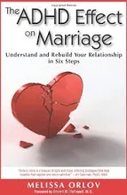
Updated in 2020! Invaluable resource for couples in which one or both partners have Attention Deficit Hyperactivity Disorder (ADHD), this authoritative book guides troubled partners towards an understanding and appreciation for the struggles and triumps of a relationship affected by it, and to integrate ADHD into their relationship in a more positive and less disruptive way. Going beyond traditional marriage counseling which can often discount the influence of ADHD, this discussion offers advice from the author’s personal experience and years of research and identifies patterns of behavior that can hurt marriages – such as nagging, intimacy problems, sudden anger and memory issues – through the use of descriptions of actual couples and their ADHD struggles and solutions. The first third of the book is dedicated to helping couples identify how ADHD impacts their relationship. The last two-thirds provides a specific set of steps couples can move through to overcome their hurt and anger, once again develop loving ways to interact with each other, and find the joy they’ve lost in their struggles. This book encourages both spouses to become active partners in improving their relationship.
The ADHD Effect is a brilliant compilation of what you can do if you are in a marriage where one or both of you have ADHD. It is a life-saver of a book..." --Dr. Edward Hallowell, co-author of Driven to Distraction
"We adore this book! It's a comprehensive guide to dealing with the impact of ADHD on your marriage without making either partner wrong..." --Kate Kelly and Peggy Ramundo, authors of You Mean I'm Not Lazy, Stupid or Crazy?!

- The Big Activity Book for Anxious People by Jordan Reid, Erin Williams Amazon Smile To Order
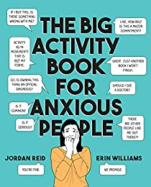
Feeling anxious? Who isn't! Your most irrational (and sometimes rational) fears are hilarious fodder for this sharp and relatable activity book.
These days, anxiety is simply part of the human experience. Part journal, part coloring book, part weird coping mechanisms, and part compendium of soothing facts, The Big Activity Book for Anxious People will be an outlet for anyone who wants to take a break from reality, laugh through her fears, and realize with every page that she is not alone--and to help her figure out what to do when it's 3AM and she's wide awake worrying about whether she cc'ed the right "Bob" on that email. (Probably.)
Activities include:
- Fun Facts about Aging!
- Public Speaking: A Diagram
- Your Hotel Room Carpet: A Petri Dish of Horrors
- Obscure Diseases You Probably Don't Have
- Zen Mantras For The Anxiously Inclined
- Soothing Facts about Hand Sanitizer
On a bad day, try coloring in the soothing grandma. On a really bad day, find step-by-step instructions on how to build an underground bunker. Reid and Williams want everyone to remember that they're in good company: anxious people are some of the funniest and most interesting and creative humans on the planet. (They know, because they are two of them.)These days, anxiety is simply part of the human experience.
From Goodreads

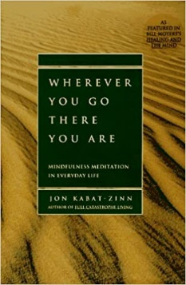
- Wherever You Go There You Are: Mindfulness Meditation in Everyday Life by Jon Kabat-Zinn Amazon Smile To Order In this book, the author maps out a simple path for cultivating mindfulness in one's own life. It speaks both to those coming to meditation for the first time and to longtime practitioners, anyone who cares deeply about reclaiming the richness of his or her moments. From Goodreads

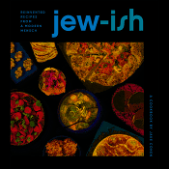
- Jew-ish: Reinvented Recipes from a Modern Mensch by Jake Cohen Amazon Smile To Order
When you think of Jewish food, a few classics come to mind: chicken soup with matzo balls, challah, maybe a babka if you’re feeling adventurous. But as food writer and nice Jewish boy Jake Cohen demonstrates in this stunning debut cookbook, Jewish food can be so much more.
In Jew-ish, he reinvents the food of his Ashkenazi heritage and draws inspiration from his husband’s Persian-Iraqi traditions to offer recipes that are modern, fresh, and enticing for a whole new generation of readers. Imagine the components of an everything bagel wrapped into a flaky galette latkes dyed vibrant yellow with saffron for a Persian spin on the potato pancake, best-ever hybrid desserts like Macaroon Brownies and Pumpkin Spice Babka! Jew-ish features elevated, yet approachable classics along with innovative creations, such as:
Jake’s Perfect Challah
Roasted Tomato Brisket
Short Rib Cholent
Jew-ish is a brilliant collection of delicious recipes, but it’s much more than that. As Jake reconciles ancient traditions with our modern times, his recipes become a celebration of a rich and vibrant history, a love story of blending cultures, and an invitation to gather around the table and create new memories with family, friends, and loved ones. A brilliantly modern take on Jewish culinary traditions for a new generation of readers, from a bright new star in the culinary world. From Goodreads

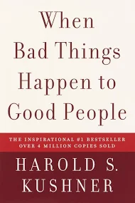
When Bad Things Happen To Good People by Harold S. Kushner Amazon Smile To Order
When Harold Kushner’s three-year-old son was diagnosed with a degenerative disease and that he would only live until his early teens, he was faced with one of life’s most difficult questions: Why, God? Years later, Rabbi Kushner wrote this straightforward, elegant contemplation of the doubts and fears that arise when tragedy strikes. Kushner shares his wisdom as a rabbi, a parent, a reader, and a human being. Often imitated but never superseded, When Bad Things Happen to Good People is a classic that offers clear thinking and consolation in times of sorrow.
Since its original publication in 1981, When Bad Things Happen to Good People has brought solace and hope to millions of readers and its author has become a nationally known spiritual leader. From Goodreads

- Chicken Soup for the Soul (The Original) by Jack Canfield, Mark Victor Hansen and Amy Newmark Amazon Smile To Order
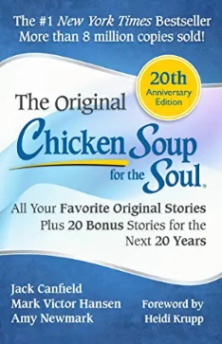
Two of America's best-loved inspirational speakers share the very best of their collected stories and favorite tales that have touched the hearts of people everywhere. Canfield and Hansen bring you wit and wisdom, hope and empowerment to buoy you through life's dark moments. From Goodreads

- The Untethered Soul by Michael A. Singer Amazon Smile To Order
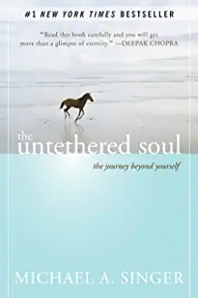
What would it be like to free yourself from limitations and soar beyond your boundaries? What can you do each day to discover inner peace and serenity? The Untethered Soul—now a #1 New York Times bestseller—offers simple yet profound answers to these questions.
Whether this is your first exploration of inner space, or you’ve devoted your life to the inward journey, this book will transform your relationship with yourself and the world around you. You’ll discover what you can do to put an end to the habitual thoughts and emotions that limit your consciousness. By tapping into traditions of meditation and mindfulness, author and spiritual teacher Michael A. Singer shows how the development of consciousness can enable us all to dwell in the present moment and let go of painful thoughts and memories that keep us from achieving happiness and self-realization.
Co-published with the Institute of Noetic Sciences (IONS) The Untethered Soul begins by walking you through your relationship with your thoughts and emotions, helping you uncover the source and fluctuations of your inner energy. It then delves into what you can do to free yourself from the habitual thoughts, emotions, and energy patterns that limit your consciousness. Finally, with perfect clarity, this book opens the door to a life lived in the freedom of your innermost being. From Goodreads

- The Four Agreements: A Practical Guide to Personal Freedom (a Toltec Wisdom Book) by Don Miguel Ruiz Amazon Smile To Order
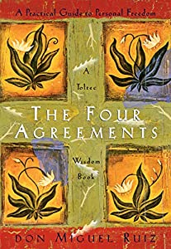
In The Four Agreements, don Miguel Ruiz reveals the source of self-limiting beliefs that rob us of joy and create needless suffering. Based on ancient Toltec wisdom, the Four Agreements offer a powerful code of conduct that can rapidly transform our lives to a new experience of freedom, true happiness, and love. The Four Agreements are: Be Impeccable With Your Word, Don't Take Anything Personally, Don't Make Assumptions, Always Do Your Best.
From Goodreads

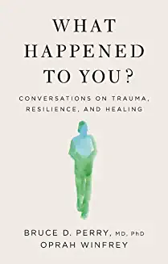
- What Happened to You? Conversations On Trauma, Resilience and Healing by Bruce D. Perry, M.D., Ph.D , Oprah Winfrey
Amazon Smile To Order
Winfrey shares stories from her own past, understanding through experience the vulnerability that comes from facing trauma and adversity at a young age. Joining forces with Dr. Perry, one of the world’s leading experts on childhood and brain development, Winfrey and Dr. Perry marry the power of storytelling with science to better understand and overcome the effects of our pasts.
In conversation throughout the book, the two focus on understanding people, behavior, and ourselves. It’s a subtle but profound shift in our approach to trauma, and it’s one that allows us to understand our pasts in order to clear a path to our future – opening the door to resilience and healing in a proven, powerful way.
All proceeds from this book are donated to the Boys and Girls Club Mississippi.
“Through this lens we can build a renewed sense of personal self-worth and ultimately recalibrate our responses to circumstances, situations, and relationships. It is, in other words, the key to reshaping our very lives.”—Oprah Winfrey

